LOW-LEVEL DESIGN DOCUMENT

**Designing a Streaming Data Pipeline with Dataflow and visualization dashboard using Looker**

Created Date: 10/04/2023

TABLE OF CONTENTS

1. Setting up of Prerequisites
2. Create Pub/Sub topic
3. create a BigQuery dataset and Table
4. Create a Cloud Storage bucket
5. Python Code to Publish messages to Pub/Sub topic
6. Data in Pub/Sub
7. Set up a Dataflow Pipeline
8. Analyze the data using BigQuery
9. Create a real-time dashboard using Looker

**Task 1.** **Setting up of Prerequisites**

1. **Activate Cloud Shell**

Google Cloud Shell is a virtual machine that is loaded with development tools. Google Cloud Shell provides command-line access to your Google Cloud resources.

* In Cloud console, on the top right toolbar, click the Open Cloud Shell button.



You can list the active account name with this command:

gcloud auth list

gcloud config list project

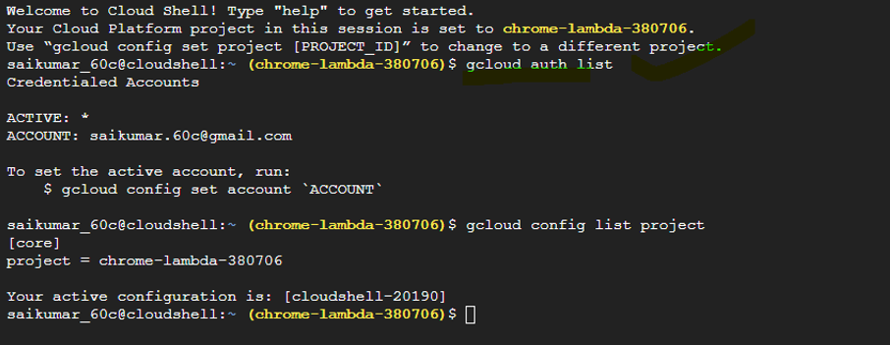

## **Confirm that needed APIs are Enabled**

In the GCP Console, in the Navigation menu, click **APIs & Services** and ensure that the following APIs are enabled:

* Cloud Pub/Sub API

* Dataflow API

**Task 2.** **Create Pub/Sub topic**

**#Approach 1**

**Creating Topic in PubSub**

* In the Cloud console, in the Navigation menu , click on PubSub > .

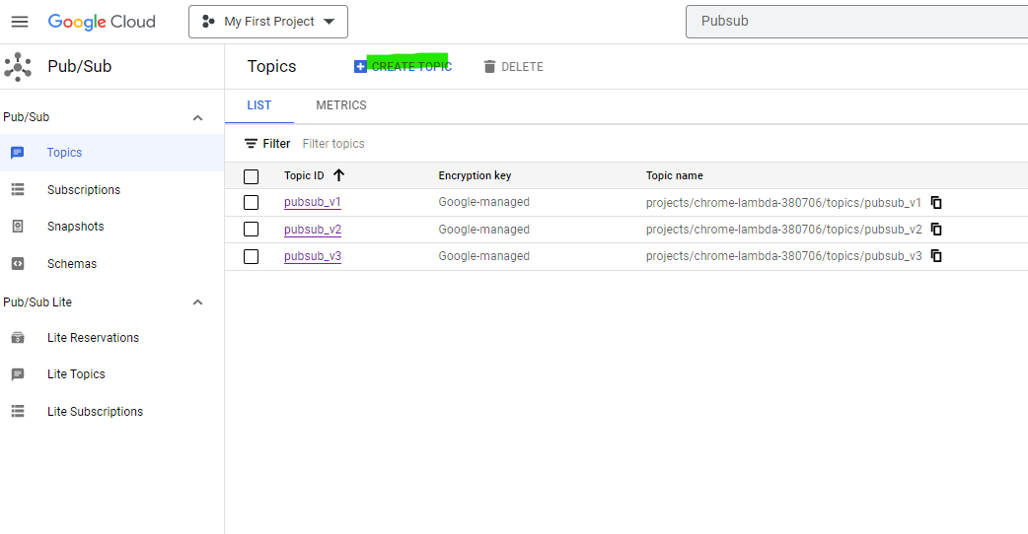

* Give topic ID pubsub_v2, then click Create Topic.

Creating topic can also be achieved using cloud shell

**#Approach 2**

Go to the Cloud Shell

Use below gcloud command create topic from cloud shell

* gcloud pubsub topics create pubsub_v2

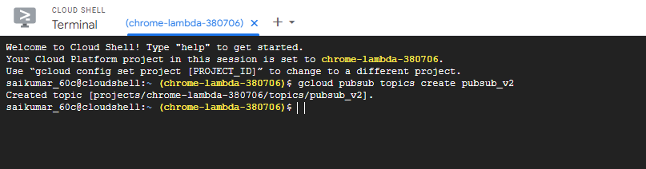

**Task 3) Creating BQ Dataset & Table**

* In the Google Cloud console, Navigateto BigQuery.
* In the explorer, next to your Project ID, Click on View actions and then click Create dataset.

* In Dataset ID, type boredAPI and select Location Type as shown below.

* In the Explorer pane, click expand node to reveal the new boredAPI dataset.
* Click on View actions next to the boredAPI dataset
* Click Create Table.
* In Table, type table name as activityDetails
* For adding the table schema, click on add fields
* Click Create Table

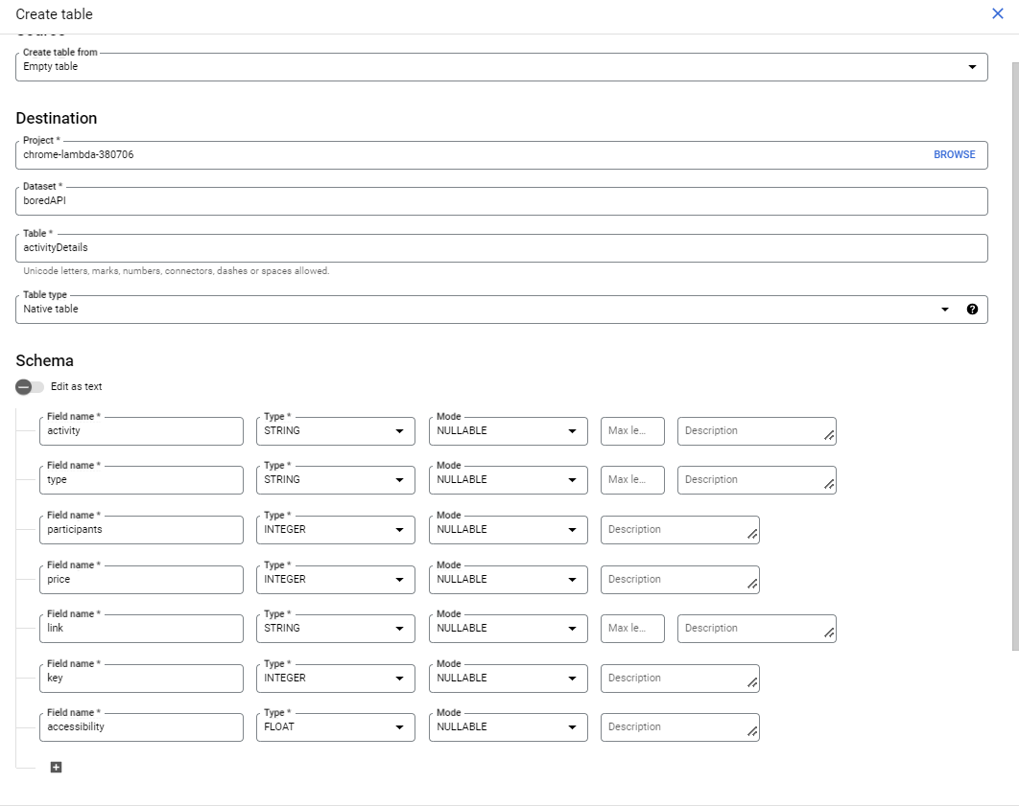

Note: Make sure add schema to the table as per website data

Sample data in the website - <https://www.boredapi.com/api/activity/>

{"**activity**":"Memorize a favorite quote or poem","**type**":"education","**participants**":1,"**price**":0,"**link**":"","**key**":"9008639","**accessibility**":0.8}

**Task 4. Create a Cloud Storage bucket**

In this task, you create a Cloud Storage bucket to provide working space for your Dataflow pipeline.

* In the Cloud console, Navigate to Cloud Storage > Buckets.
* Click Create Bucket.
* Give the bucket name same as Project ID, and then click Continue.
* Click Create.

**Task 5. Python Code to Publish messages to Pub/Sub topic**

**a)** Use Visual Studio code in your system to run the below pip commands in the terminal to Install the required libraries

* pip install google.cloud
* pip install google-cloud-pubsub
* pip install -U requests

**b) create a service account to access the Google cloud from Visual Studio code**

* In the Cloud console, navigate to IAM & Admin > Service accounts.
* In the top menu bar, click Create Service Account
* In Service Account name, type Streaming Data
* Click on Create and Continue
* In select role Search for Pub/Sub Publisher and click on continue and Done Graphical user interface, text, application, email

  Description automatically generated

* Click on that service account you have created
* Click on **Keys** and **ADD KEY** and **Create New Key**
* Choose Key Type as Json and this will download the .json file to your Local system

**c) Python code to extract the website data to Pubsub topic**

Run the below code in Visual Studio Code and this code will trigger/refresh website -https://www.boredapi.com/api/activity/ and store the data into Pub/Sub Topic(pubsub_v2)

In the credentials path give the path of .json key that you have downloaded in the previous step.

from google.cloud import pubsub_v1

from pip._vendor import requests

#import pip._vendor.requests

import time

import os,ssl

credentials_path=r'C:\Users\Saikumar Cheppa\Downloads\chrome-lambda-380706-76cc3c25caf2.json'

os.environ['GOOGLE_APPLICATION_CREDENTIAL'] =credentials_path

api="https://www.boredapi.com/api/activity/"

publisher=pubsub_v1.PublisherClient()

topic_path='projects/chrome-lambda-380706/topics/pubsub_v2'

while True:

    response=requests.request("GET", api, verify=False).text

    publisher.publish(topic_path, data=response.encode('utf-8'))

    time.sleep(15)

>To tun the code right click on the code and select ‘Run Python File in Terminal

**Task 6) Verify the data in Pub/Sub**

To check Streaming data in Pub/Sub

* In the Cloud console, navigate PubSub >
* In Topics click on **pubsub_v2**(topic created in task 1)and thenclick on **pubsub_v2-sub**

* Click on Messages and then click on PULL to check If data is streaming with latest timestamp or not

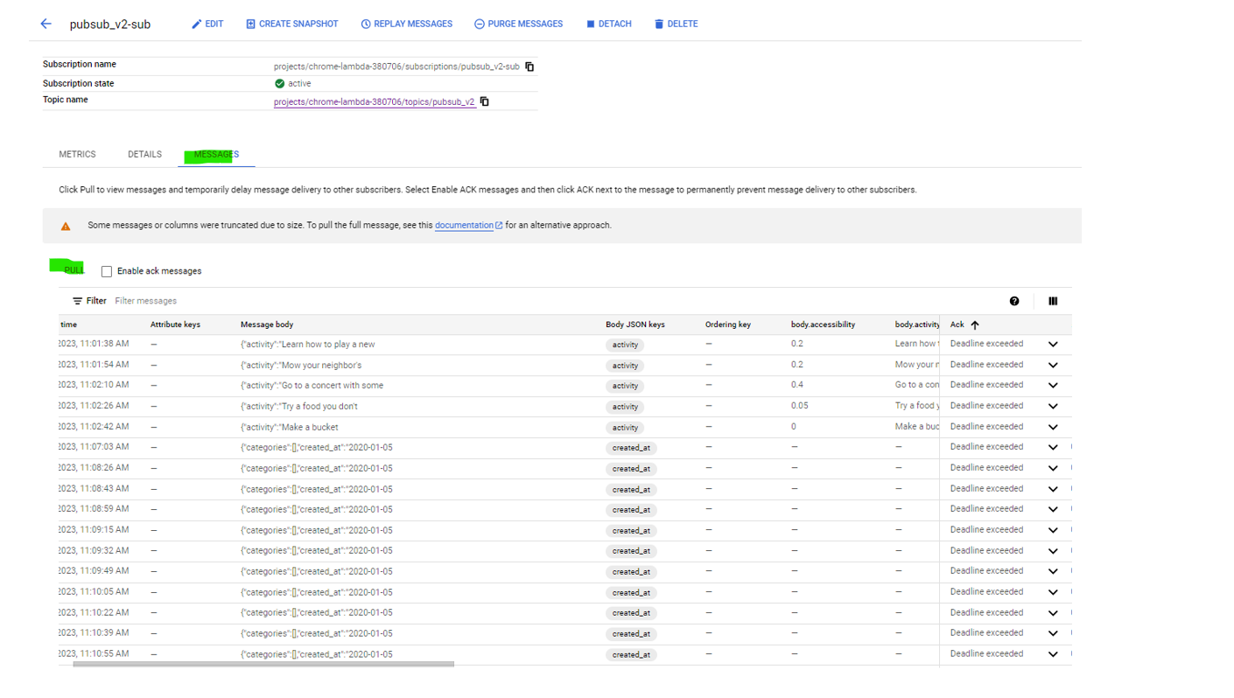x

**Task 7. Set up a Dataflow Pipeline**

Once the data available in Pub/Sub and now create Dataflow Template

**Create a new streaming pipeline:**

* In the Cloud console, Navigateto Dataflow.
* In the top menu bar, click Create Job from Template.
* Type streaming-activityDetails-pipeline-Bored API as the Job name for your Dataflow job.
* In Regional endpoint, select us-central1 (Iowa).
* In Dataflow template, select the Pub/Sub Topic to BigQuery template.
* In Input Pub/Sub topic, select the topic that already exists in your project from the dropdown list . It will appear like the following:

**projects/<myprojectid>/topics/pubsub_v2**

* In BigQuery output table, Click on browse and select table as activityDetails
* In Temporary location, click Browse.
* Click view child resources(view child resources).
* Click Create new folderand then type the name tmp.
* Click Create, and then click Select tmp folder.
* Click Show Optional Parameters.
* In Max workers, type 2
* In Number of workers, type 1
* Click Run Job.

A new streaming job has started! You can now see a visual representation of the data pipeline. It will take 3 to 5 minutes for data to begin moving into BigQuery.

**Task 8. Analyze the data using BigQuery**

In this task, you analyze the data as it is streaming.

* In the Cloud console, navigate to BigQuery.
* In the Query Editor, type the following, and then click Run:

select * from chrome-lambda-380706.boredAPI.activityDetails

**Note:** If no records are returned, wait another minute and re-run the above query (Dataflow takes 3-5 minutes to setup the stream).

**Task 9. Create a real-time dashboard using Looker**

* In the Query Editor, clear the current query.
* Copy and paste the following query, and then click Run

select

activity, type,participants, link, accessibility

 from chrome-lambda-380706.boredAPI.activityDetails

* Click Save > Save query.
* In the Save query dialog, in the Name field, type **My Saved Query**.
* Click Save.

* In BigQuery, click Explore Data > Explore with Looker Studio.

* Looker Studio Opens as below

* In the Looker Studio window, customize your reporting dashboard as per requirement

